**CSC 238 – Human Computer Interface Design**

California State University, Sacramento (CSUS)

Computer Science Department

Spring – 2024.

Team Members – Aravind Yuvraj, Rajasekhar Reddy K, Kundana Lingala, Nithin Gogineni

**Assignment** – Digital Mockup Second Iteration

Figma Link - [Figma](https://www.figma.com/design/dEHhT5AxuMfsZTCkDM8Ypq/Master's-Project-Management-System-Website?node-id=16%3A10&t=GidVUiUuzEOrxn2Y-1)

* Interface Design Update:

Link to the design: [Students Submissions Page](https://www.figma.com/design/dEHhT5AxuMfsZTCkDM8Ypq/Master's-Project-Management-System-Website?node-id=68%3A624&t=uok67VGcanBDNwv9-1)

In our latest iteration, we focused on refining the decision-making buttons like Approve, Reject, and pending to ensure that they are more visually distinct and appealing to the users.

Approve: Green colored, to indicate a positive action.

Reject: Red, to indicate a negative action.

Pending: Yellow, to signify an action that is on hold or requires further attention.

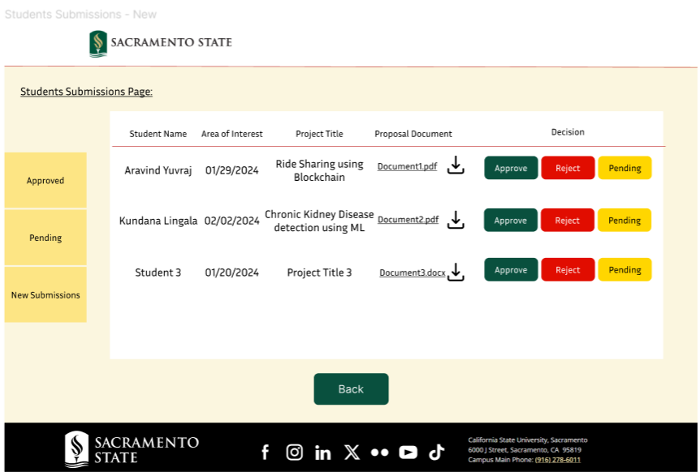

* Button Shape and Style:

Link to the design: [Proposal Upload Page](https://www.figma.com/design/dEHhT5AxuMfsZTCkDM8Ypq/Master's-Project-Management-System-Website?node-id=42%3A42&t=uok67VGcanBDNwv9-1)

We have redesigned the buttons with modern, flat design aesthetic and matching them with contemporary web design trends. It not only looks cleaner but also enhances the interface’s overall usability by providing a clear visual cue. Also, the buttons are uniformly sized and aligned, making an organized look. This consistency helps in reducing visual clutter and improving the navigational flow of the page.

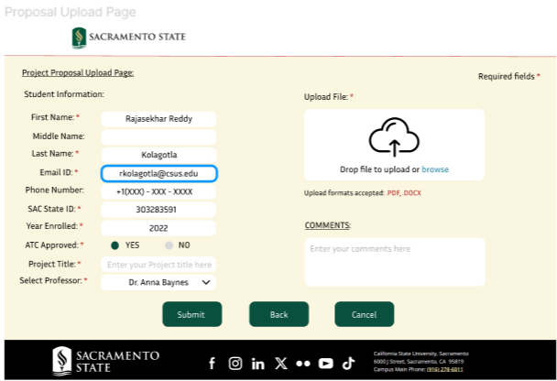

* Added new designs for Graduate Co-Ordinator Approvals.

Link to the design: [Graduate Coordinator Dashboard Page](https://www.figma.com/design/dEHhT5AxuMfsZTCkDM8Ypq/Master's-Project-Management-System-Website?node-id=151%3A192&t=uok67VGcanBDNwv9-1)

Added a new task for documentation approvals uploaded to the portal by students. This task is designed to allow the graduate coordinator to view and manage project documents that require approval. Each document can be reviewed and approved directly from this interface, streamlining the process and enhancing efficiency. The dashboard layout is designed to provide quick access to the most used features used by graduate coordinator with vibrant colors to ensure they are immediately noticeable. The color scheme and design patterns reflect the university’s branding, promoting a cohesive and professional appearance.

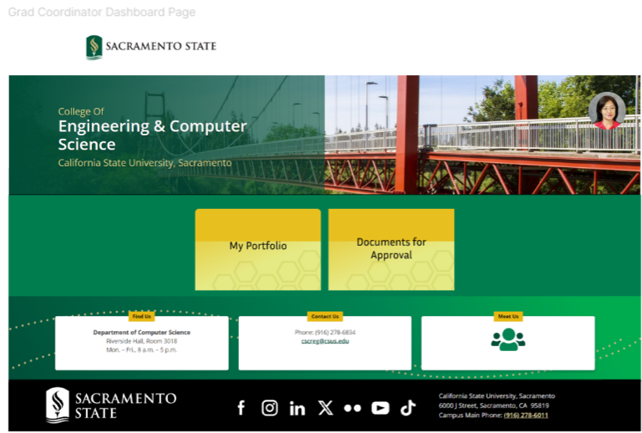

* Enhanced pop-up notifications feature.

Link to the design: [Action confirmation popup message](https://www.figma.com/design/dEHhT5AxuMfsZTCkDM8Ypq/Master's-Project-Management-System-Website?node-id=149%3A127&t=uok67VGcanBDNwv9-1)

We designed/added popup notification feature to convey the result of an action in clear and straightforward language. For example, when student proposal/documents are approved, the popup clearly states, “You have successfully accepted the student proposal !!” This eliminates any ambiguity about the outcome of the action. This provides immediate feedback to an action done by the user.

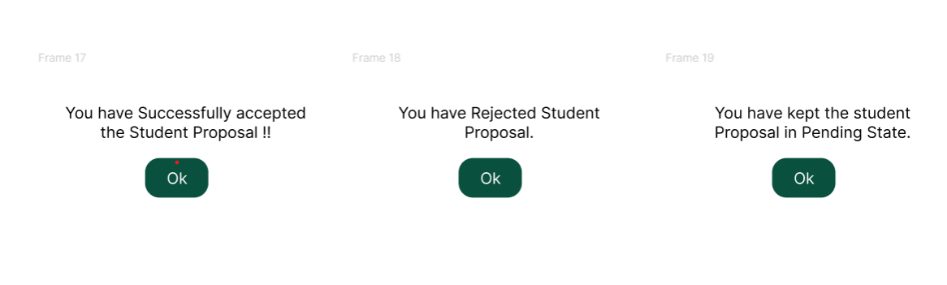

**Contribution Statement**

**Rajasekhar Reddy Kolagotla** contributed 25% to the team, effectively coordinated with the team to ensure timely completion of assignments and maintained clear, professional communication throughout the project. Worked on the group assignment documentations. I designed some webpages for the Home, login, forgot password, help and password reset pages. Additionally, I modified the button designs as per Sac State website. I am also responsible for conducting interviews with professors.

**Aravind Yuvraj** contributed 25% to the team. I worked on one of the tasks where student submits his/her project proposal. I designed the student dashboard, list of available professors, proposal upload pages. I also made sure that the design patterns match the Sac State website. Created a workflow for the student version. I also made sure the pop-up screens and buttons are actively working without any issues. Overall, these efforts were aimed at creating a user-friendly and visually appealing website that meets the needs and preferences of our targeted audience.

**Kundana Lingala** contributed 25% to the team, worked on various pages like submissions and feedback, student profile, Track your progress, professor profile pages. I also made all the flow connections, updated all the button designs. In addition, I was responsible for creating a pop-up message when clicked on buttons and asking for confirmation. Developed initial Figma designs according to the paper prototypes. Participated in design and feature discussions.

**Nithin Gogineni** contributed 25% to the team. I worked on the task where professor checks out the student proposals and accept their ideas. The design pages include Professor Dashboard, Professor portfolio, Submissions pages. Made some changes to the design patterns by adjusting color and font to maintain consistency across the website. I am responsible for conducting interviews with various graduate level students and get their feedback on the Master’s project.